

Coursework 1

Student Name: Anmol Vishvas

Student Number: M00734701

Date of Submission: 10th December 2021

Module Code: CST2120

Module Name: Web Applications and Databases

Tutor: Ameerah Assotally

Game Website Report – Final Submission

Table of Contents

**1.** **Game description** 2

**2.** **Website Features** 2

**2.1.** **Home** 2

**2.2.** **Registration and Login** 3

**2.2.1.** **Registration** 3

**2.2.1.1.** **Validation of user data** 3

**2.2.1.1.1.** **Errors handling** 3

**2.2.1.1.2.** **Data entered correctly** 4

**2.2.1.2.** **Data Storage** 5

**2.2.1.2.1.** **Local Storage** 5

**2.2.1.2.2.** **Session Storage** 5

**2.2.2.** **Login** 5

**2.2.2.1.** **Validation of user data** 6

**2.2.2.1.1.** **Error handling** 6

**2.2.2.1.2.** **Data entered correctly** 7

**2.2.2.2.** **Data Storage** 8

**2.2.2.2.1.** **Session storage** 8

**2.2.3.** **Menu Bar** 8

**2.3.** **How To Play** 9

**2.4.** **Game** 10

**2.4.1.** **Game Controls** 10

**2.4.2.** **Additional features added in the game** 11

**2.4.2.1.** **Different difficulty levels** 11

**2.4.2.1.1.** **Beginner Level** 11

**2.4.2.1.2.** **Intermediate Level** 11

**2.4.2.1.3.** **Advanced Level** 12

**2.4.2.2.** **Audio** 12

**2.4.3.** **Game Over** 12

**2.5.** **Leaderboard** 13

**2.5.1.** **How scores will be stored?** 13

**2.5.2.** **How final scores are calculated?** 13

**2.5.3.** **How is the leaderboard table populated?** 14

**2.6.** **Contact Us** 14

**2.7.** **Logout** 14

Racing Car Game Website

# **Game description**

Racing car game is a single player game that uses the arrow keys to control a car. The player will have to dodge the incoming cars. The game can be played in three different difficulty levels, as follows:

* ‘beginner’ level: the car is set to the maximum speed of 140 KPH and three lives will be given to the user
* ‘intermediate’ level: the car is set to the maximum speed of 190 KPH and two lives will be given to the user
* ‘advanced’ level: the car is set to the maximum speed of 200 KPH and one life will be given to the user;

When the game is over, a message will be shown with the final score.

# **Website Features**

There are eight features in the game website which are called “Home”, “Register”, “Login”, “How to Play”, “Game”, “Leaderboard”, “Contact us” and “Logout”.

## **Home**

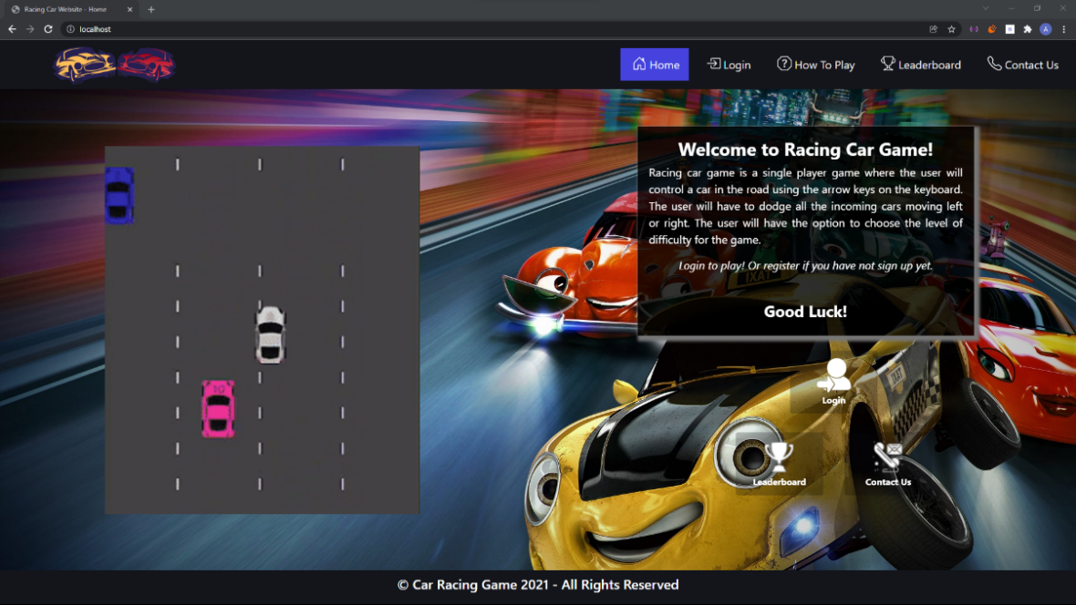

Figure - Racing Car Website - Home page

Home page is the welcoming page where an animation of the game and a window containing a welcome message with the description of the game are displayed. When we are in the homepage, the home button in the navigation bar will be highlighted in blue to show the current page.

Three buttons are located in the right side of the page. They can be used to access the various sections of the website.

Once logged in, the login button will be disabled.

## **Registration and Login**

### **Registration**

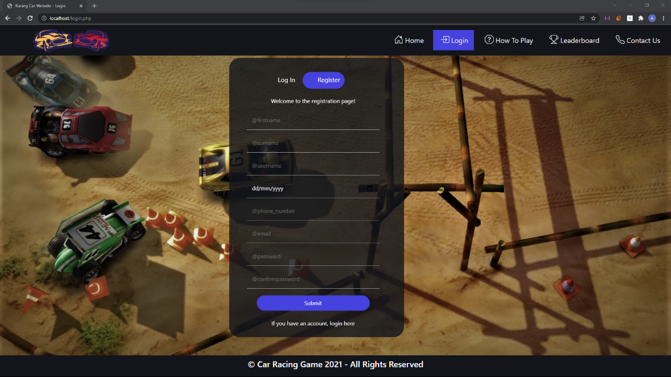

Figure - Racing Car Website - Registration Section

Registration page will allow a new user to register. Only registered users are permitted to play the game. There are eight mandatory input fields for the user to complete in this part, which are as follows:

* First name,
* Surname,
* Username,
* Date of birth,
* Phone Number,
* Email address,
* Password,
* Confirm Password.

#### **Validation of user data**

##### **Errors handling**

When a user presses the submit button, the website checks to see if any required fields were missed. The user will be notified with an error message if fields are empty, as seen in figure 3.



Figure - Error message when input field is empty

The website will perform a second check to ensure that the user has entered valid data for all fields, such as having more than three characters for first name, surname and username (*figure 4*), ensuring that the phone number has at least eight characters (*figure 5),* ensuring that a valid email address has been entered (*figure 6)*, and checking that the entered password and confirm password are matching (*figure 7)* and do not contain any special characters, and so on.

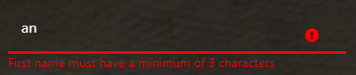

Figure 4- Validation of first name, surname, username input fields

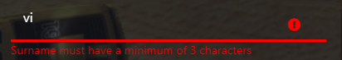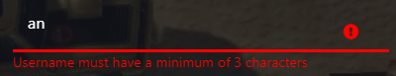

Figure 5- Validation for phone number input field



Figure 6- Validation for Email input field

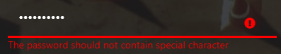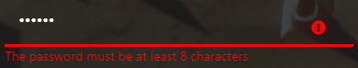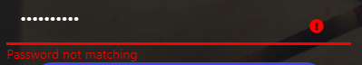

Figure 7- Validation for password and confirm password input fields

A last check will be made to see if the username is already in the local storage (*figure 8).*

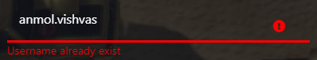

Figure 8- Validation of username input field

##### **Data entered correctly**

The border of each input field will be green if the user data submitted matches all criteria. An account will be established for the user automatically, saved to local storage, and the user will be prompted that an account has been created.

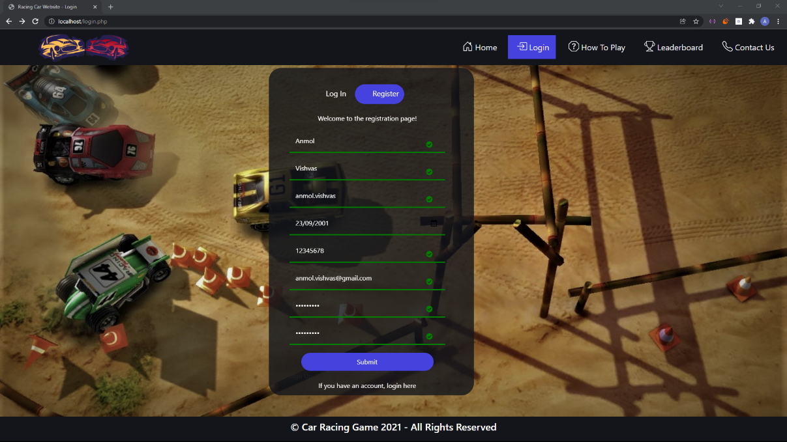

Figure 9- Racing Car Website- Registration section when user data submitted meets all criteria.

A message will appear on the screen to notify the user that the account was successfully created using the sweet alert feature (*figure 10*).

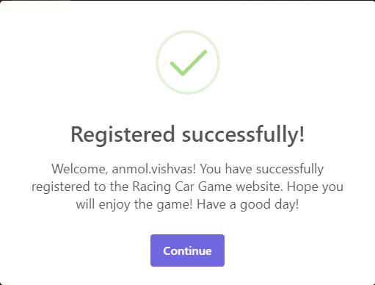

Figure 10- Sweet alert feature used to display a success message for the registration section

#### **Data Storage**

##### **Local Storage**

The user's data will be saved in the local storage after submission (*figure 11*).

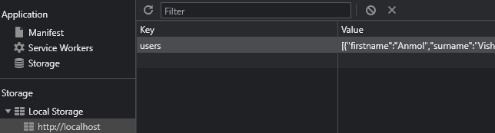

Figure 11- Data Stored in Local Storage

##### **Session Storage**

When a user registers, the username is saved in the session storage (*figure 12*).

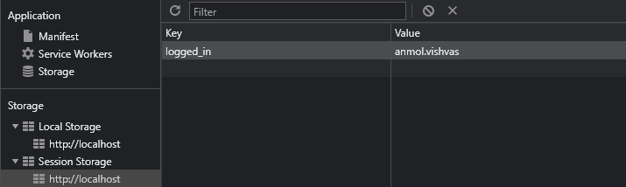

Figure 12- Data Stored in Session Storage

### **Login**

A registered player can play the game only after logging in. The user will be asked for a username and password.

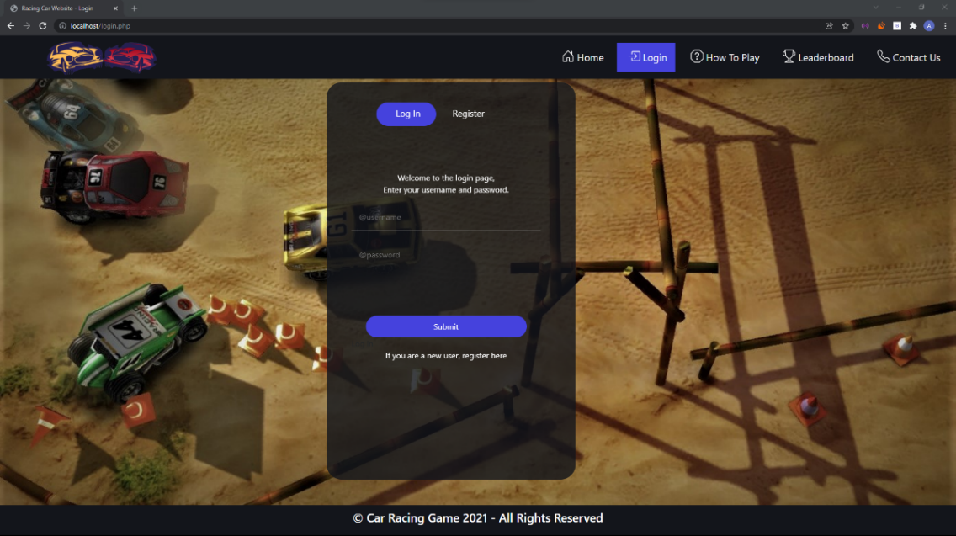

Figure 13- Racing Car Website- Login Section

#### **Validation of user data**

After that, the website will perform tests to see if access should be permitted or not.

##### **Error handling**

When a user presses the submit button, the website checks to see if any required input fields were missed. If the answer is yes, the latter will be notified with an error message about which fields are empty (*figure 14*).

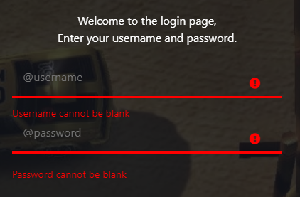

Figure 14- Validation of login section's data

The website will then perform a second check to see if the data provided is present in the data stored in local storage. If this is not the case, an error message will appear telling the user that the data entered is invalid (*figure 15*).

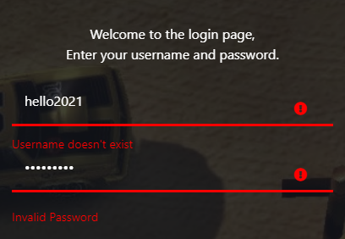

Figure 15- Validation of data provided

##### **Data entered correctly**

The border of each input field will be green if the user data submitted matches all criteria. A popup will appear on the screen after the username is saved in the session storage (*figure 16*).

A message will appear on the screen using the sweet alert feature to inform the user that they have successfully signed in (*figure 17*). 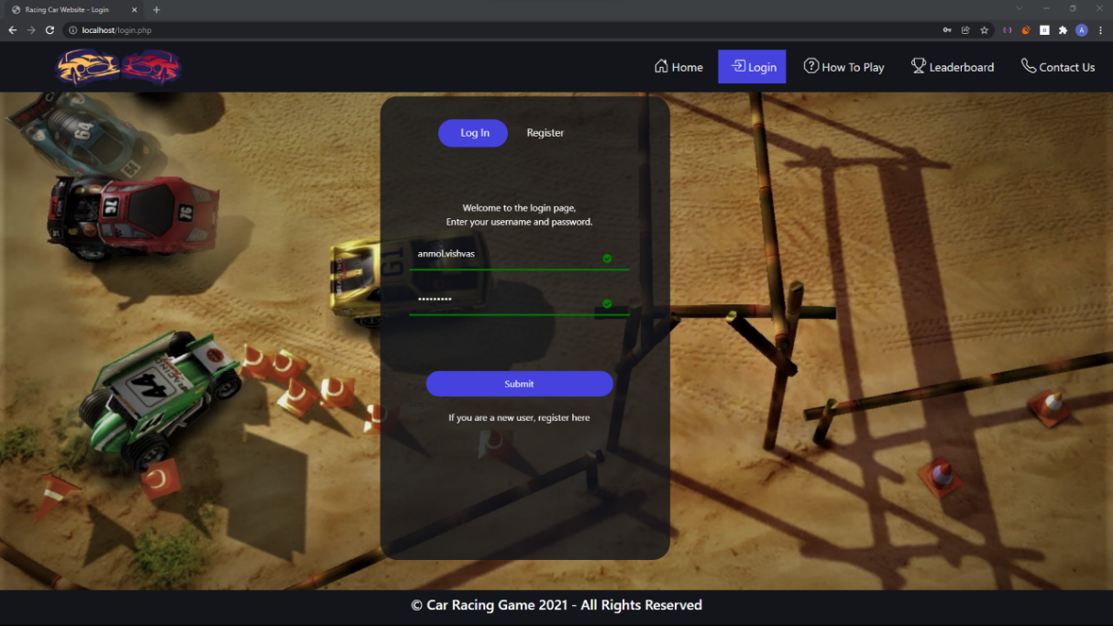

Figure 16- Racing Car Website- Login section when the data entered meets all criteria.

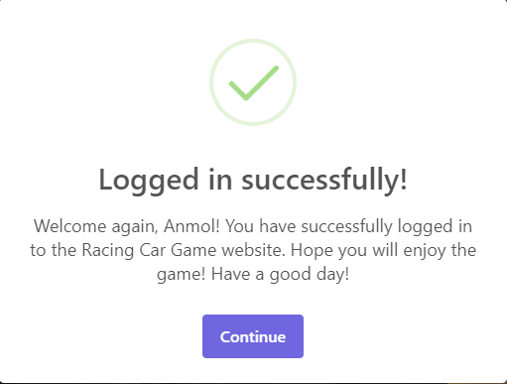

Figure 17 - Sweet alert feature used to display a success message for the login section

#### **Data Storage**

##### **Session storage**

When a user logs in, the username is saved in the session storage (figure 18).

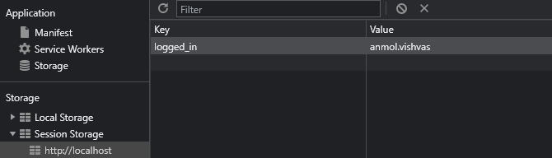

Figure 18- Data stored in session storage

### **Menu Bar**

To complete the registration and login process, once the registration form is submitted, the user will be directed to the 'how to play' page, with the 'login' menu disappearing from the navigation bar and the logout menu appearing in its place (*figure 19*).



Figure 19- Navigation Bar once registered

## **How To Play**

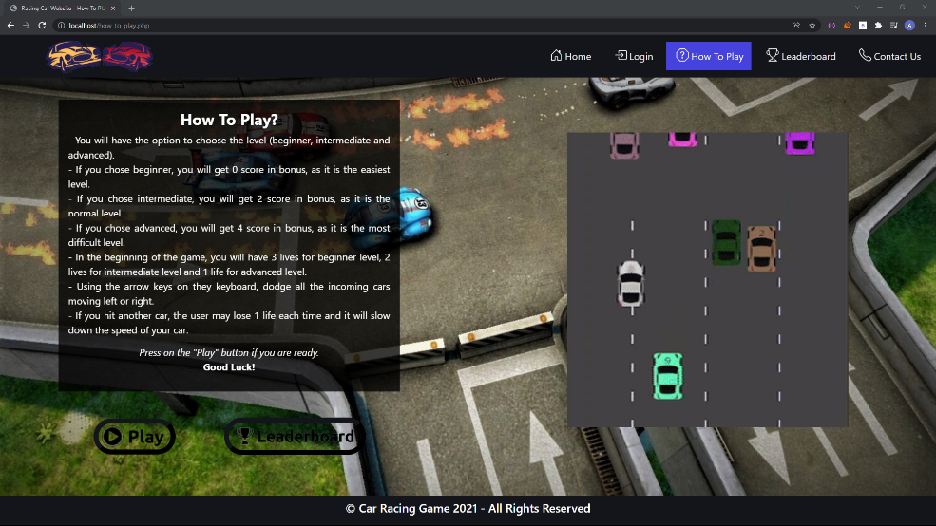

Figure 20- Racing Car Website - How to Play page

After registering and logging in, the user will be led to the how play page, which will have instructions on how to play the game. There are two buttons on the left side, under the guidelines, as seen in *figure 20*. The game page will be loaded if the user has logged in. if not, an error will be displayed (*figure 21*). The user will be directed to the leaderboard page by clicking the leaderboard button. The game's animation is displayed on the right side of the website.

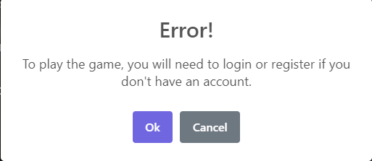

Figure 21- Error message if user didn't log in or didn't register yet

## **Game**

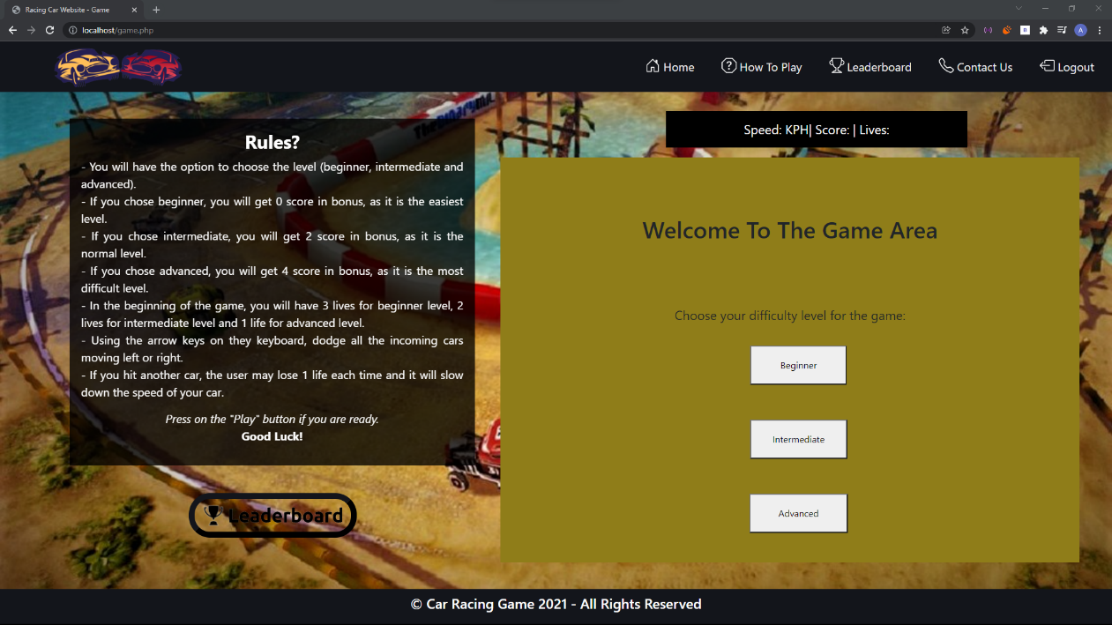

Figure 22- Racing Car Website - Game Page

The game page is depicted in *figure 22*. The rules of the game are displayed on the left side, and there is a leaderboard button under the instructions.

The dashboard and gaming area are located on the right side of the screen. The user will be given the choice of selecting a difficulty level. The number of bonus points awarded varies depending on the difficulty level selected.

### **Game Controls**

To move the car, the user must use the arrow keys on the keyboard. The user must use the arrow up key to increase speed and the arrow down key to reduce speed. If the player overtakes a car, his score will increase by one, and if the car hits another one, one life point is lost.

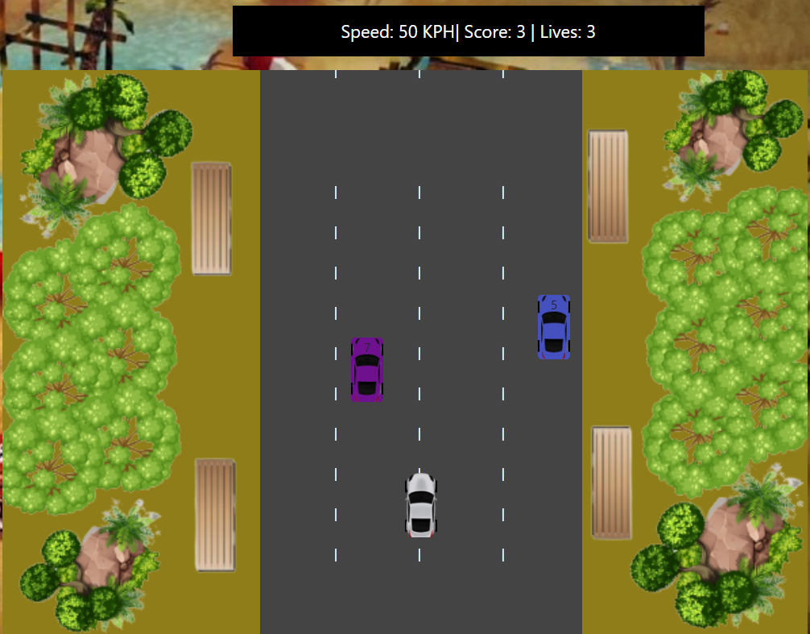

Figure 23- Overview of the Game and Dashboard

### **Additional features added in the game**

Some additional features were added in the game, such as different difficulty levels and audio.

#### **Different difficulty levels**

##### **Beginner Level**

The first level is the beginning level, which will display a confirmation message once the user selects that option (*figure 24*).

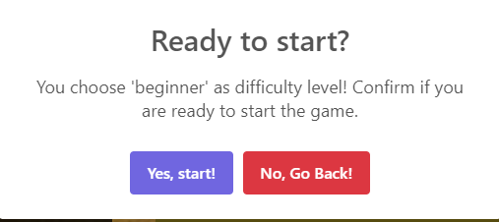

Figure 24- Confirmation message before starting the Game

If the user is ready to start the game, he will be prompted to press the "yes, start!" button, after which the game will begin. The player will remain on the same page as seen in *figure 22* if they click the "No, Go Back!" button.

The highest speed assigned for the beginner level is 140 KPH, and the player will begin the game with three lives.

##### **Intermediate Level**

The intermediate level is the second level; once the user selects that option, a confirmation message appears (*figure 25*).

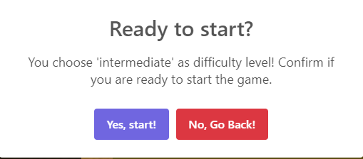

Figure 25- Confirmation message before starting the Game

The maximum speed assigned for the intermediate level is 190 KPH, the player will start the game with just two lives, and the user will receive two additional points in the score.

##### **Advanced Level**

The advanced level is the final level; after the user selects that choice, a confirmation message appears (*figure 26*).



Figure 26- Confirmation message before starting the Game

The maximum speed set for the advanced level is 200 KPH, the player will start the game with just one life, and the user will receive four bonus points in the score.

#### **Audio**

A sound of a driving car will play as soon as the game begins. An accident automobile sound will be played if the user collides with another vehicle. When the game is finished, the other two sounds will stop, and a game over sound will play.

### **Game Over**

When the game is finished, a pop-up message will open with the player's score and the choice to restart the game or proceed to the leaderboard page (*figure 27*).

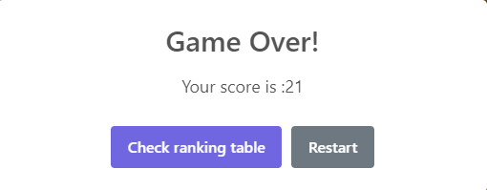

Figure 27- Game over pop up

If the player wants to restart the game, a new pop-up will appear, giving him or her the option of selecting the difficulty level (*figure 28*).

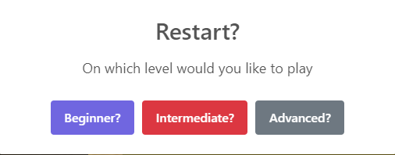

Figure - Game Over restart pop up

## **Leaderboard**

### **How scores will be stored?**

The user's details will be displayed on the leaderboard table (*figure 29*) as soon as the user registers, and the score will be set to 0 in the local storage (*figure 30*).

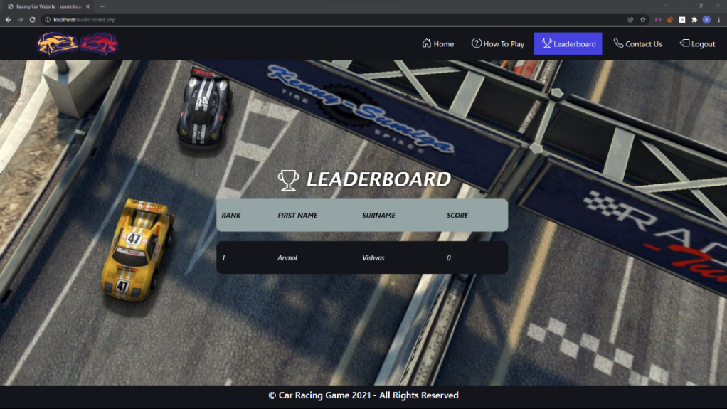

Figure 29- Racing Car Website - Leaderboard

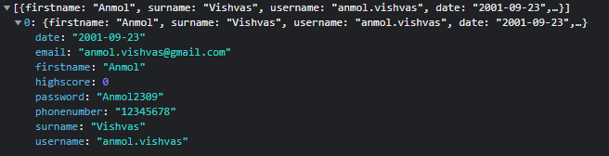

Figure 30- How score is stored in the local storage

### **How final scores are calculated?**

Example: if the user’s car passed 6 cars.

|  |  |  |  |  |
| --- | --- | --- | --- | --- |
| Levels | Number of lives | Car passed | Bonus Points | Final Score |
| Beginner | 3 | 6 | 0 | **6** |
| Intermediate | 2 | 6 | 2 | **6+2=8** |
| Advanced | 1 | 6 | 4 | **6+4=10** |

### **How is the leaderboard table populated?**

Only the top five scores will be displayed on the leaderboard. The website will load all data from local storage into an object array and sort the object array by highest points using bubble sort and reverse array when users load this page.

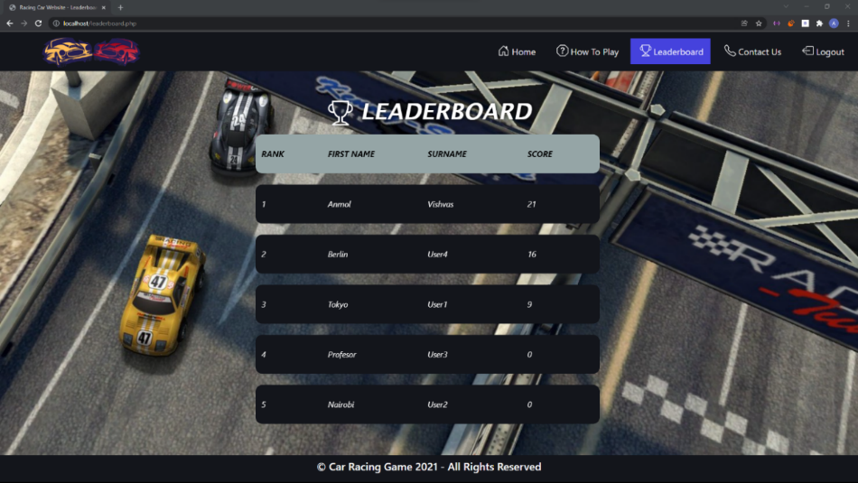

Figure 32- Racing Car Website - Leaderboard

## **Contact Us**

On this section, the contact details are provided.

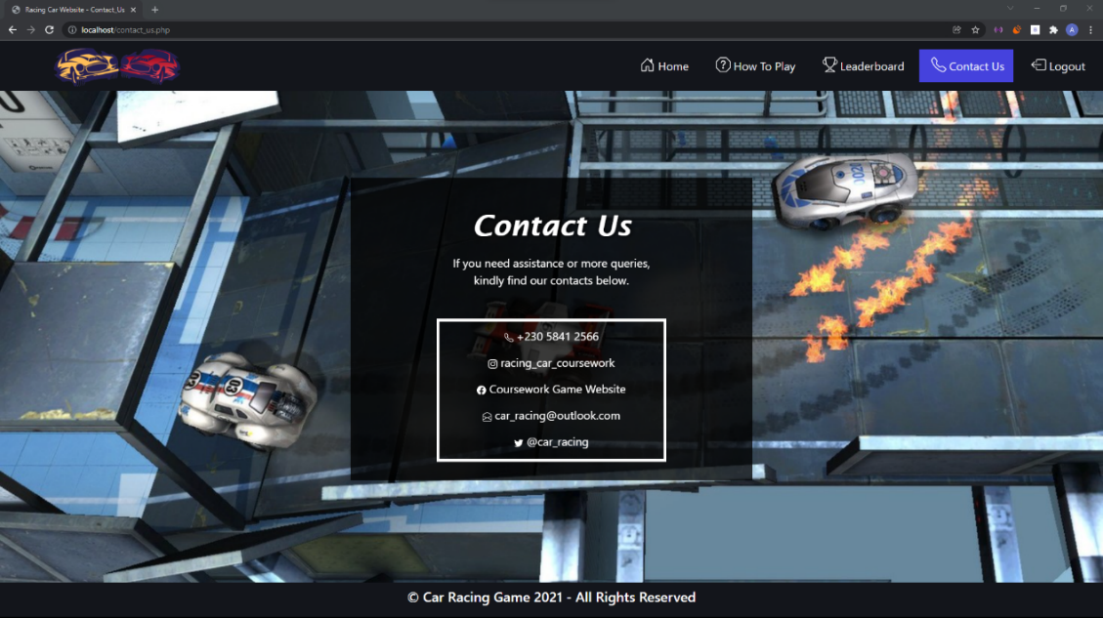

Figure 33- Racing Car Website - Contact Us

## **Logout**

Finally, pressing the 'logout' option on the navigation bar clears the session storage, allowing the 'login' menu to appear in the navigation bar and the logout menu to disappear (*figure 34*).



Figure 34- Navigation Bar once logged out